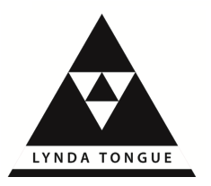
Developmental
Transactional
Analysis

For practitioners who support
others to grow and develop

Developmental Transactional Analysis (DTA) focusses on the development and growth of individuals, and also takes into account that TA is a social psychology – we live and work in groups and communities.

If you are considering applying TA in organisations either as a coach or a trainer etc, then you might want to consider adding another field at CTA.

EATA recently announced that for those wishing to add CTA in another field

“the previous training followed in another
field by the candidate can be counted”.

Therefore, if you are already CTA in one field, and you have the means to gather sufficient hours (or you have already accrued hours) of application in a second field, your hours of TA training will count towards the second CTA field.

You may also be eligible to gain accreditation of prior learning towards the MSc.

You may also be interested in other qualifications accredited through Middlesex University and conducted at centres around the UK. Lynda Tongue offers DTA workshops and supervision groups based in Torquay, Devon. Lynda also offers supervision over skype or phone to support candidates to achieve MSc or CTA status.

Contact Lynda Tongue through the website, details below.

For more information and a booking form
contact Lynda Tongue via the website
www.lyndatongue.com

