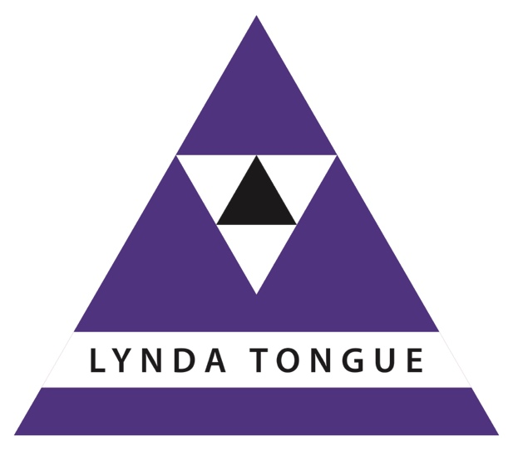
Introduction to
Transactional Analysis
(TA 101)

A framework of psychological tools and concepts for coaches, trainers, youth workers, consultants, teachers, managers …..

Official Introductory Course
Transactional Analysis (TA) can be applied by anyone, in a variety of situations. It has an underlying ethos of positive regard for self and others, and a belief that everybody can change. This two day workshop is the official introduction prescribed by the European Association for Transactional Analysis (EATA) and is an internationally recognised qualification.

What is Transactional Analysis?
TA is a framework for understanding professional and personal relationships, communication, and human behaviour. The interlocking concepts and models of TA promote clear communication, and help people to reach their true potential.

TA was founded by Eric Berne in the 1950s and is widely used in Organisations, Education, Counselling and Psychotherapy.

What are the benefits of attending this workshop?
TA helps us to understand why we think the way we do, why we behave the way we do and what we can do to change what we want to change. This is a benefit in our working lives, and in our personal lives. This course will help you if you:

- Want to understand human behaviour
- Want to know why communication can break down
- Are interested in your personal and professional development

How can I use this course?
- For personal interest and development
- As a foundation for further study of TA
- In your work with colleagues, team members, managers, in youth work, in voluntary work, with clients and with friends

Programme Outline

Ego States (Parent, Adult, Child)
- Personality parts
- Structure and function – where are you coming from?
- Transactions – how can I change?
Useful when: dealing with angry, or smothering or negative people

Script Analysis
- What’s in my history? What can I do about it?
- The Script matrix – a model for understanding what lies behind behaviour
- Injunctions and permissions – personal growth and development
Useful when: confidence is low; building self esteem

Psychological Game Analysis
- Why do we play games?
- How do we avoid playing?
- The Drama Triangle
Useful when: dealing with bullying; building confidence, developing others

Racket Analysis
- Internal process – self limiting beliefs
- Trading stamps
- Autonomy and change – how to overcome our rackets
Useful when: dealing with stressful situations

Psychological hungers and patterns
- Strokes
- Time structuring
- Stimulation
Useful when: managing individuals and teams; managing self

TA Community
- How it all comes together
- Schools of TA
- Different applications

For details
Contact Lynda Tongue through the website: www.lyndatongue.com/contact

